Topic-1 The First World War, Khilafat and Non-Cooperation Movement
- Effects of First World War:
- The First World War led to a huge increase in defence expenditure. This was financed by war loans and by increasing taxes. Custom duties were raised and income tax was introduced to raise extra revenue. Prices of items increased during the war years. The prices doubled between 1913 and 1918. The common people were the worst sufferers because of the price rise. Forced recruitment of rural people in the army was another cause of widespread anger amongst people.
- Crop failure in many parts of India resulted in an acute shortage of foods. Influenza epidemic further aggravated the problem. According to the 1921 census, about 12 to 13 million people died because of famines and epidemic.

The Idea of Satyagraha
- Mahatma Gandhi returned to India in January 1915. His heroic fight for the Indians in South Africa was wellknown. His noble method of mass agitation known as Satyagraha that had yielded good results.
- The idea of Satyagraha emphasised the power of truth and the need to search for truth. In 1916, Gandhi travelled to Champaran in Bihar to inspire the peasants to struggle against the oppressive plantation system.
- The method of Satyagraha was based on the idea that if someone is fighting for a true cause, there is no need to use any physical force to fight the oppressor. Gandhiji believed that a satyagrahi could win a battle through non-violence, i.e., without being aggressive or revengeful.

Some early Satyagraha movements organised by Gandhiji :
- Peasants’ Movement in Champaran (Bihar) in 1916.
- Peasants’ Movement in Kheda district (Gujarat) in 1917.
- Mill workers’ Movement in Ahmedabad in 1918.

The Rowlatt Act (1919) :
- The Rowlatt Act was passed by the Imperial Legislative Council in 1919. The Indian members did not support the Act, but it was passed nevertheless. The Act gave enormous powers to the British Government to repress political activities. It allowed detention of political prisoners without trial for two years.
- On 6th April, 1919; Gandhiji launched a nationwide Satyagraha against the proposed Rowlatt Act. The call of a strike on 6th April got a huge response. People came out in support in various cities, shops were shut down and workers in railway workshops

went on strike. The British administration decided to clamp down on the nationalists. Several local leaders were arrested. Mahatma Gandhi was barred from entering Delhi.

Jallianwala Bagh :
- On 10th April 1919; in Amritsar; the police fired upon a peaceful procession. This provoked widespread attacks on government establishments. Martial Law was imposed in Amritsar and the command of the area was given to General Dyer.
- The infamous (shocking) Jallianwala Bagh Massacre took place on 13th April; the day on which Baisakhi is celebrated in Punjab. A crowd of villagers came to participate in a fair in Jallianwala Bagh. It was enclosed from all sides with narrow entry points.
- General Dyer blocked the exit points and opened fire on the crowd. Hundreds of people were killed in that incident. Public reaction to the incident took a violent turn in many north Indian towns. The government was quite brutal in its response. Things turned highly violent turn. Mahatma Gandhi called off the movement as he did not want to continue the violence.

Khilafat Movement :
- The Khilafat issue gave Mahatma Gandhi an opportunity to bring the Hindus and Muslims on a common platform. The Ottoman Turkey was badly defeated in the First World War. There were rumours about a harsh peace treaty likely to be imposed on the Ottoman emperor; who was the spiritual head of the
- Islamic world (the Khalifa). A Khilafat committee was formed in Bombay in March 1919 to defend the Khalifa. This committee had leaders like the brothers Muhammad Ali and Shaukat Ali. They also wanted Mahatma
- Gandhi to take up the cause to build a united mass action. At the Calcutta session of the Congress in September 1920, the resolution was passed to launch a Non- Cooperation Movement in support of Khilafat and also for Swaraj.

Non-Cooperation Movement :
- In his famous book Hind Swaraj (1909), Mahatma Gandhi declared that British rule was established in India with the cooperation of Indians and had survived only because of this cooperation. If Indians refused to cooperate, British rule in India would collapse within a year, and Swaraj would be established.
- Gandhiji believed that if Indians begin to refuse to cooperate, the British rulers will have no other way than to leave India.
- Some of the proposals of Non-Cooperation Movement :
  - Surrender the titles which were awarded by the British Government.
  - Boycott of civil services, army, police, courts, legislative councils and schools.
  - Boycott of foreign goods.
  - Launch full civil disobedience campaign, if the government persisted with repressive measures.

Differing Strands within the Movement :
The Non-Cooperation-Khilafat Movement began in January 1921.
Various social groups participated in this movement, each with its own specific aspiration. All of them responded to the call of Swaraj, but the term meant different things to different people.
Awadh: The peasants’ movement in Awadh was led by Baba Ramchandra. He was a sanyasi who had earlier worked in Fiji as an indentured labourer. The peasants were against the high rents and may other cesses, which were demanded by talukdars and landlords. The peasants demanded reduction of revenue, abolition of the begar, and social boycott of oppressive landlords.
Tribal Peasants: Tribal peasants gave their own interpretation of Mahatma Gandhi and the idea of swaraj. The tribals were prevented from entering the forests to graze cattle, or to collect fruits and firewood. The new forest laws were a threat to their livelihoods. The government forced them to do the begar on road construction.
Many rebels from the tribal areas became non-violent and often carried guerrilla warfare against the British officials.
Swaraj in the Plantations: The plantation workers were not permitted to leave the tea gardens without permission; as per the Indian Emigration Act of 1859. When the news of Non-Cooperation Movement spread to the plantations, many workers began to defy the authorities. They left plantations and headed towards their homes. But they got stranded on the way because of a railway and steamer strike. They were caught by the police and brutally beaten up.

Topic-2 Civil Disobedience Movement

Simon Commission
- The British government constituted a Statutory Commission under Sir John Simon. The Commission was made to look into the functioning of the constitutional system in India and suggest changes. But since all the members in the Commission were British, the Indian leaders opposed the Commission.
- The Simon Commission arrived in India in 1928. It was greeted with the slogan ‘Go back, Simon’. All parties joined the protest. In October 1929, Lord Irwin announced a vague offer of ‘dominion status’ for India but its timing was not specified. He also offered to hold a Round Table Conference to discuss the future Constitution.

Salt March (Beginning of Civil Disobedience Movement)
- Mahatma Gandhi believed that salt could be a powerful symbol to unite the whole nation. Most of the people; including the British scoffed at the idea. Abolition of the salt tax was among many demands which were raised by Gandhiji through a letter to Viceroy Irwin.
- The Salt March or Dandi March was started by Gandhiji on 12th March 1930. He was accompanied by 78 volunteers. They walked for 24 days to cover a distance of

240 miles from Sabarmati to Dandi. Many more joined them on the way. On 6th April 1930, Gandhiji ceremonially violated the law by taking a fistful of salt.
- The Salt March marked the beginning of the Civil Disobedience Movement. Thousands of people broke the salt law in different parts of the country. People demonstrated in front of government salt factories. Foreign cloth was boycotted. Peasants refused to pay revenue. Village officials resigned. Tribal people violated forest laws.

Response of British Rulers:
The colonial government began to arrest the Congress leaders. This led to violent clashes in many places. Mahatma Gandhi was arrested about a month later. People began to attack the symbols of British rule; such as police posts, municipal buildings, law courts and railway stations. The government’s repression was quite brutal. Even women and children were beaten up. About 100,000 people were arrested.

Round Table Conference:
When things began to take a violent turn, Mahatma Gandhi called off the movement. He signed a pact with Irwin on 5th March 1931. This was called the Gandhi-Irwin Pact. As per the Pact, Gandhiji agreed to participate in the Round Table Conference in London. In lieu of that, the government agreed to release the political prisoners. Gandhiji went to London in December 1931. The negotiations broke down and Gandhiji had to return with disappointment. When Gandhiji came back to India, he found that most of the leaders were put in jail. Congress had been declared illegal. Many measures were taken to prevent meetings, demonstrations and boycotts. Mahatma Gandhi relaunched the Civil Disobedience Movement. By 1934, the movement had lost its momentum.
Topic-3 People’s Participation in the Movement and the Sense of Collective Belonging
- Farmers: For the farmers, the fight for Swaraj was a struggle against high revenues. When the movement was called off in 1931; without the revenue rates being revised; the farmers were highly disappointed. Many of them refused to participate when the movement was re-launched in 1932. The small tenants just wanted the unpaid rent to the landlord to be remitted. They often joined the radical movements which were led by Socialists and Communists. Congress did not want to alienate the rich landlords and hence, the relationship between the poor peasants and Congress was uncertain.
- Businessmen: The Indian merchants and industrialists could grow their business during the First World War. They were against those colonial policies which restricted their business activities. They wanted protection against imports and a Rupee-Sterling Foreign Exchange ratio which would discourage imports. The Indian Industrial and Commercial Congress was formed in 1920 and the Federation of the Indian Chamber of Commerce and Industries (FICCI) was formed in 1927. These were the results of attempts to bring the common business interests on a common platform. For the businessmen, Swaraj meant an end to oppressive colonial policies. They wanted an environment which could allow the

business to flourish. They were apprehensive of militant activities and of growing influence of socialism among the younger members of the Congress.
- Industrial Workers: The industrial workers showed a lukewarm response to the Civil Disobedience Movement. Since, industrialists were closer to the Congress, workers kept a distance from the movement. But some workers selectively participated in the movement. Congress did not want to alienate the industrialists and hence, preferred to keep the workers’ demands at bay.
- Women’s Participation: Women also participated in the Civil Disobedience Movement in large numbers. However, most of the women were from high-caste families in the urban areas and from rich peasant households in rural areas. But for a long time, the Congress was reluctant to give any position of authority to women within the organisation. The Congress was just keen on the symbolic presence of women.

The Sense of Collective Belonging
- Nationalist Movement spreads when people belonging to different regions and communities begin to develop a sense of collective belongingness. The identity of a nation is most often symbolized in a figure an image.
- This image of Bharat Mata was first created by Bankim Chandra Chattopadhyay in 1870 when he wrote ‘Vande Mataram’ for our motherland. Indian folk songs and folk tales sung by bards played an important role in making the idea of nationalism. In Bengal, Rabindranath Tagore and in Madras, Natesa Sastri collection of folk tales and songs, this led the movement for folk revival.
- During the Swadeshi Movement, a tri-color (red, green and yellow) flag was designed in Bengal. It had eight lotuses representing eight provinces and a crescent moon representing Hindus and Muslims.
- Means of creating a feeling of nationalism was through reinterpretation of history. The nationalist writers urged the readers to take pride in India’s great achievements in the past and struggle to change the miserable conditions of life under British rule.

Map Work
Important Sessions of Indian National Congress
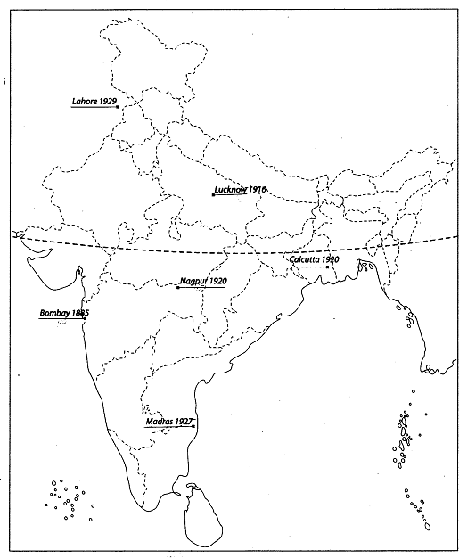
This map shows the Important Sessions of Indian National Congress from 1885 to 1947.

Important Centres of Freedom Movement in India
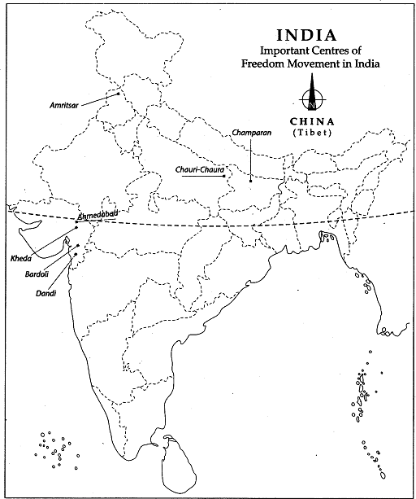
This map shows the important centres of the freedom movement in India from 1857 to 1947.

